Lab 1 Report

Setting up MASM32 and running our Hello World code…. 😉

First, we install MASM32 from the official website <https://masm32.com/>

To install MASM32 we follow some step which are

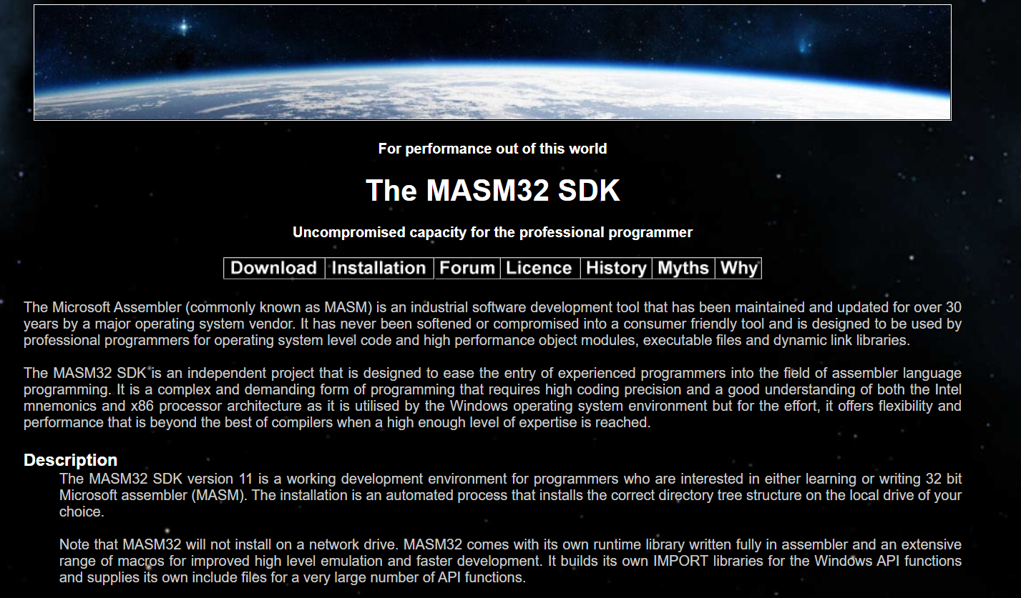

Go to the Download tab.

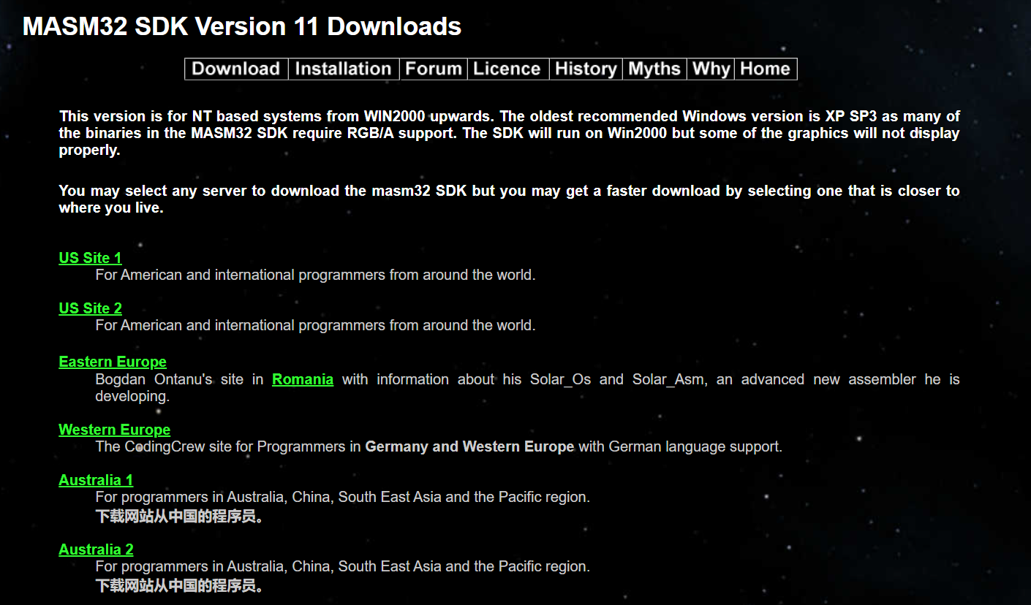

And select the Western Europe to download the setup.

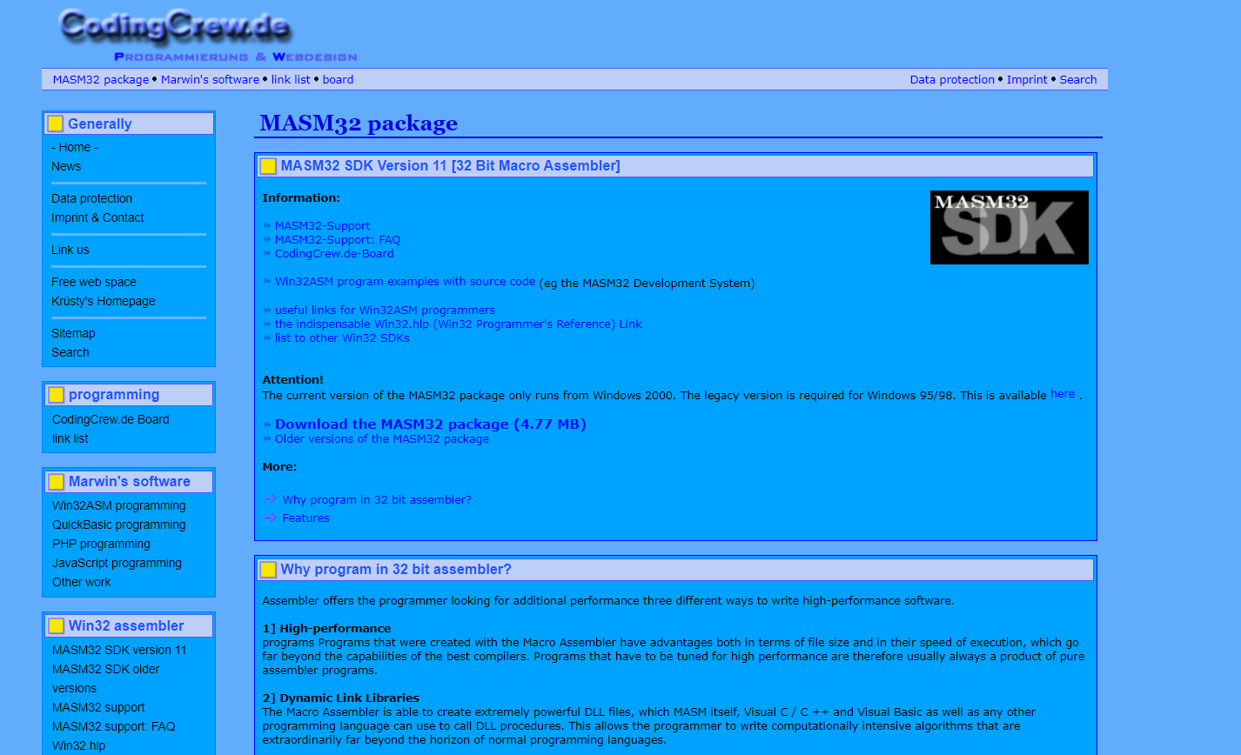

Click on **download the MASM32 package.**

Once the downloading is completed install the setup by just clicking ok.

Once the setup is installed open the MASM32 Editor from desktop.

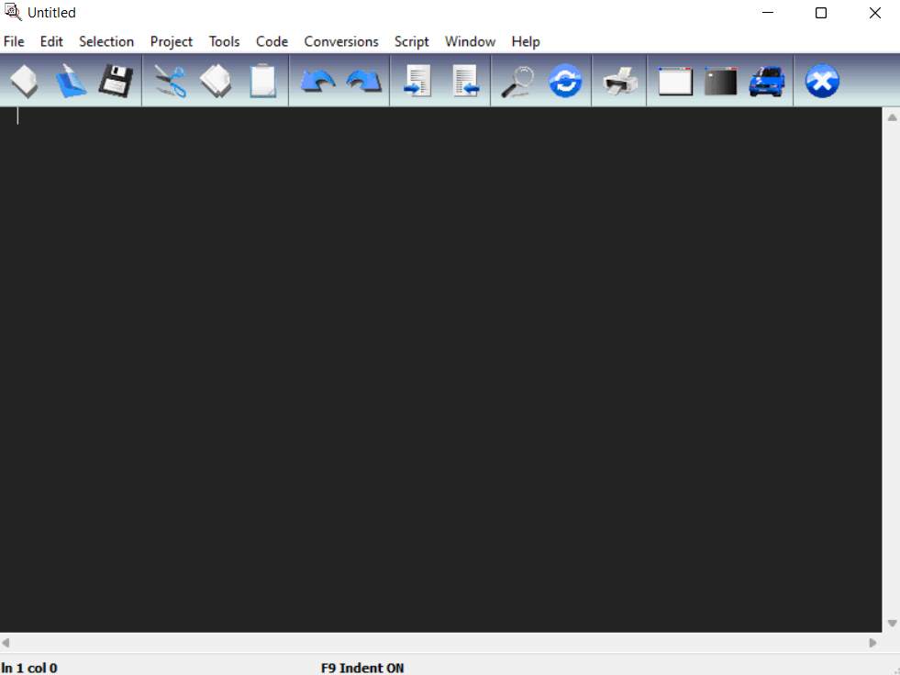

After that we write some code in it.

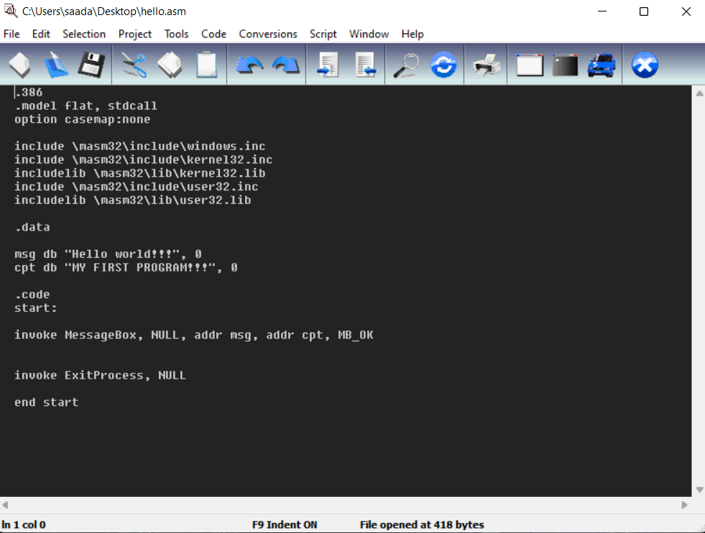

Now in menu bar select **Project** tab and click on **Build All.**

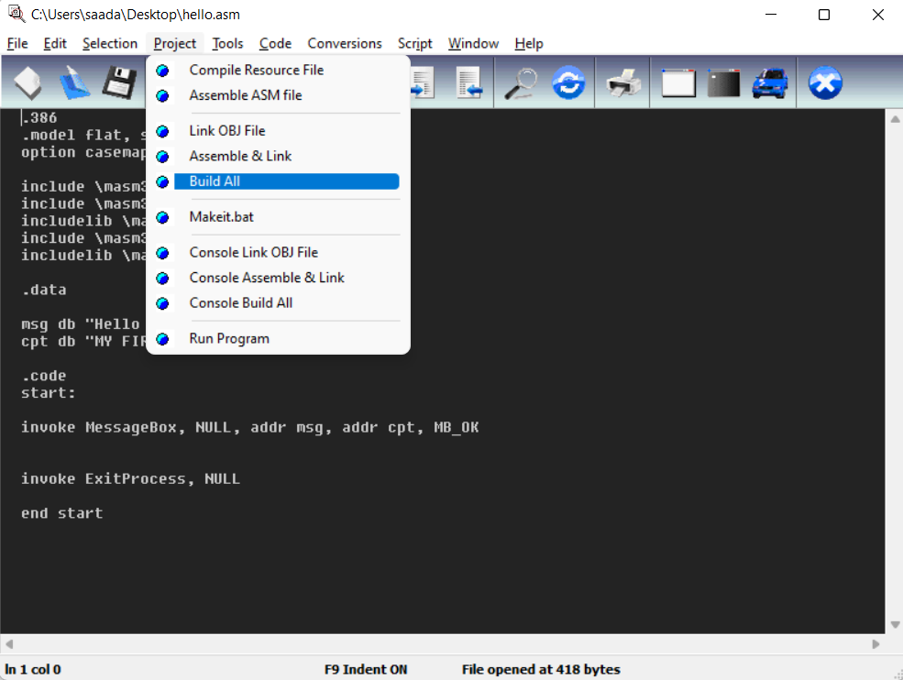

Once this is done, we will open our command prompt and type some commands and after that we will run our **executable file** which was created by **build all** option in MASM32 editor.

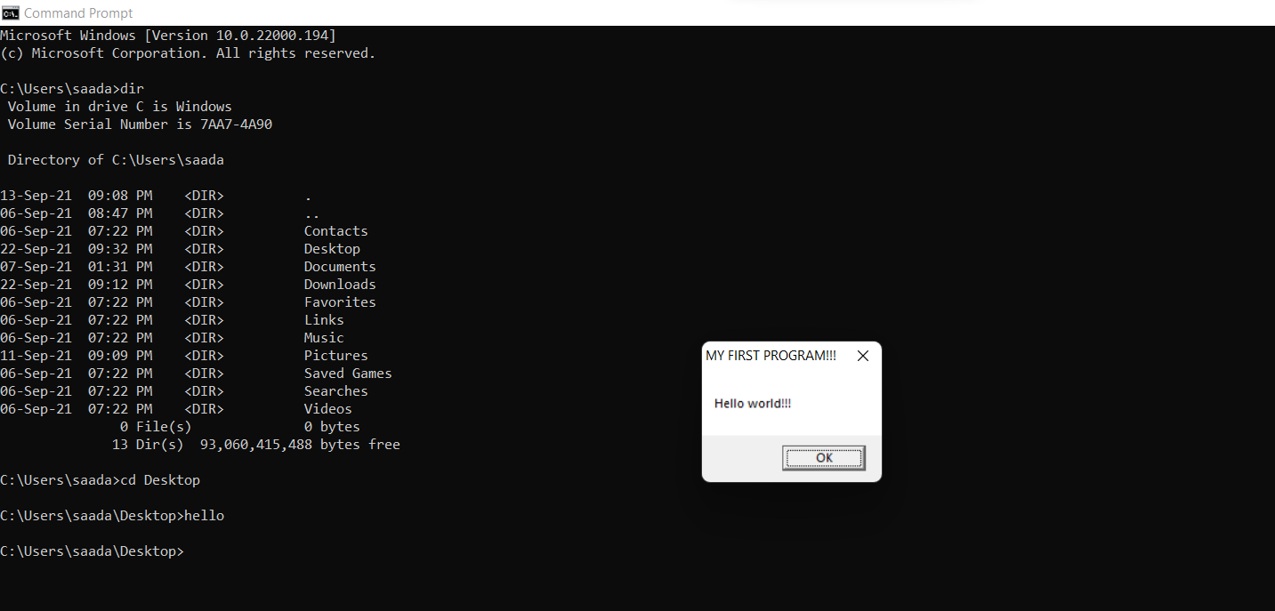

And we will see the about dialog box as our output.